Assignment 5

By Shardul Negi

(001898181)

**Problem Statement**

You will perform more experiments to test that the depth/height of a Binary Search Tree after M (Hibbard) deletions and insertions will be proportional to the square root of NwhereNis the size of the tree whenMis large. The consequence of this is that deletion, search and insertion will all end up being ***O***(N^1/2) instead of ***O***(lg N) which is what we would prefer.

**Implementation Details**

The main has been implemented for inserting and deleting X keys from the tree and checking the depth of the tree once created. Once done, I have used the following methods to calculate the result.

1: put(): will give the rand numbers to insert values to the tree

2: Delete() : will give rand numbers to delete values from the tree

3: size(): Will calculate the size of the tree. .

**Experiments**

On setting the value from 200(tree size) we insert and delete the key pair for the tree.

We will get the following relation in this.

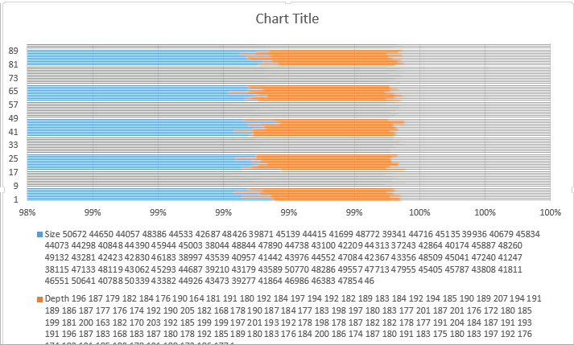

Since Peach and Light blue is demonstrated by the Size and Root of N, we can see a clear relation between the two being equal. The console results are below and in the HTML file provided in the project.

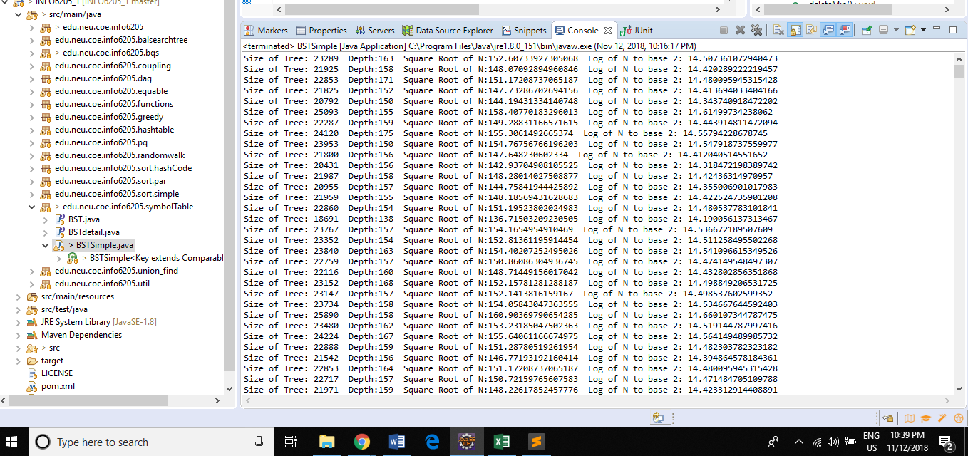

As shown, the depth and the square root is coming to be almost equal in the 1000 tests that I ran for the tree.

**Unit Test**

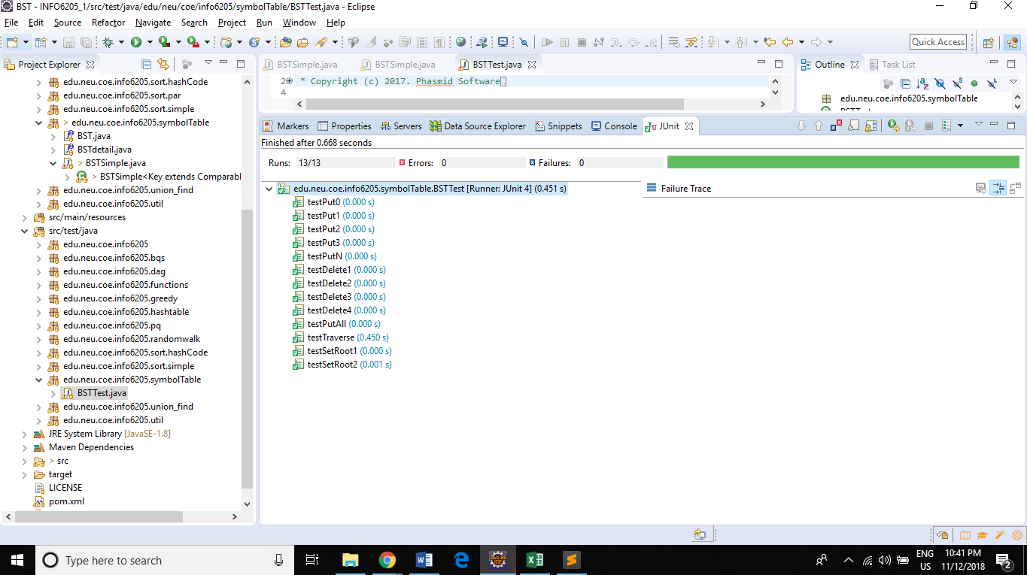

All the Jnunit test passed. One change has been made to the eQueue and Dequeue given by the professor.

**Conclusion**

The relation has been derived and mapped with respect to insert and deletion of the tree.